Template for the international Workshop on Water Waves and Floating Bodies (Times New Roman, Bold-face, 14-point and Center)
Author Names(s): First Name Middle Family Name
(Times New Roman, bold-face, 12-point and center, with underlined presenting author)
Department Affiliation, School or Company Affiliation, City, Country (12-point and center)
E-mail Address of the presenting author (12-point and center)

HIGHLIGHTS (Optional)
The authors are requested to write the highlights of the abstract here in 3 - 4 lines.

1 INTRODUCTION
The abstract should not exceed four pages in length.

  - Page Size
The use of the A4 paper (210 mm x 297 mm) is required, and the body of abstract should be written in an area of 170 mm x 245 mm. The setup of the margins is indicated in this page. DO NOT number the pages, please.

1.2 Text
The body of the text should be single spaced, in 12-point, Times New Roman (or LaTeX default) font. (Using 11-point font is also allowable, but must not be smaller than that).

1.3 Figures
The proceedings will be printed in Black and White. Authors should make sure that all figures are readable when printed in BW. The caption should be centered and in 10-point font, see example in fig. 1.
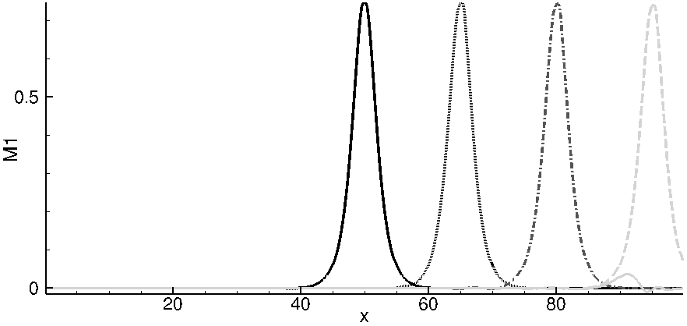
Figure 1: Example of figures
1.4 References
List of References should be arranged in the order with which the sources are cited in the text, an Arabic number is allocated for each reference so that it can be used to cite it in the text between square brackets. For example here, the first cited source is the book [1]. The list of reference should be written Times New Roman 10-point font with the title of the paper, book, report in italics.
Below, you can find an example of the References style.
REFERENCES
[1] Rowling, J. K. 1997. Harry Potter and the Philosopher’s Stone. (Bloomsbury).
[2] Kardar, M., Parisi, G., Zhang, Y.C., 1986. Dynamic scaling of growing interfaces. Phys. Rev. Letters, 56(9), 889-892.

